Probability Lab 1
Question 1
Code
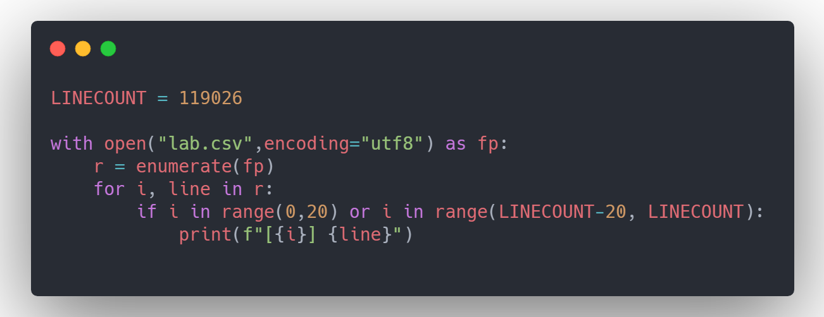
Output
[0] text,,,,,,,,,,,,,,,,,,,,,,,,,,,,,,,,,,,,,,,,,,,,,,,,,,,,,,,,,,,,,,,,,,,,,,,,,,,,,,,,,,,,,,,,,,,,,,,,,,,,,,,,,,,,,,,,,,,,,,,,,,,,,,,,,,,,,,,,,,,,,,,,,,,

[1] "The chance is unlikely if not done programmatically. However, imagine the game spawning multiple players at a spawn point, this would be the exact same location. I'm not quite sure what you mean with spin, what does the integer reflect?",,,,,,,,,,,,,,,,,,,,,,,,,,,,,,,,,,,,,,,,,,,,,,,,,,,,,,,,,,,,,,,,,,,,,,,,,,,,,,,,,,,,,,,,,,,,,,,,,,,,,,,,,,,,,,,,,,,,,,,,,,,,,,,,,,,,,,,,,,,,,,,,,,,

[2] "Why is it a mismatch between data and structure? The structure does not assume a set amount of objects, it can be anything, that's why new nodes are created. It simply makes sure that there are not more than X leafs inside 1 node. The random is no option of course. My splitting algorithm always created the maximum amount of nodes already, split over the current node. But I guess I have to change this behaviour?",,,,,,,,,,,,,,,,,,,,,,,,,,,,,,,,,,,,,,,,,,,,,,,,,,,,,,,,,,,,,,,,,,,,,,,,,,,,,,,,,,,,,,,,,,,,,,,,,,,,,,,,,,,,,,,,,,,,,,,,,,,,,,,,,,,,,,,,,,,,,,,,,,,

[3] "Actually, all the books have different authors. And most have a different location too. There will be some with the same location, but different authors, though. I think my
library should be able to store books with the same position. There are never equally-attractive leaf nodes. If a node is split, all childs will reflect a different part of the parent node. The problem is when there are too many objects with the exact same location, as they will be put in their child (there is only 1 child that fits).. and that child will do the same, etc.",,,,,,,,,,,,,,,,,,,,,,,,,,,,,,,,,,,,,,,,,,,,,,,,,,,,,,,,,,,,,,,,,,,,,,,,,,,,,,,,,,,,,,,,,,,,,,,,,,,,,,,,,,,,,,,,,,,,,,,,,,,,,,,,,,,,,,,,,,,,,,,,,,,

[4] "Your tie-breaker would force me to change my splitting method of dividing the node over multiple child nodes, each reflecting a different part of the parent. This would make the structure a lot more complex.",,,,,,,,,,,,,,,,,,,,,,,,,,,,,,,,,,,,,,,,,,,,,,,,,,,,,,,,,,,,,,,,,,,,,,,,,,,,,,,,,,,,,,,,,,,,,,,,,,,,,,,,,,,,,,,,,,,,,,,,,,,,,,,,,,,,,,,,,,,,,,,,,,,

[5] In,which,platform,r,u,working..?,Winforms,or,WPF..?,,,,,,,,,,,,,,,,,,,,,,,,,,,,,,,,,,,,,,,,,,,,,,,,,,,,,,,,,,,,,,,,,,,,,,,,,,,,,,,,,,,,,,,,,,,,,,,,,,,,,,,,,,,,,,,,,,,,,,,,,,,,,,,,,,,,,,,,,,,

[6] "Good idea. I guess I can not respect the maxChildsPerNode if all objects have the same position. I am having problems to find out whether there is no meaningful way to perform to plit or whether all childs have the same position though.. mainly because of strange float calculations. Eg. floatTopX = 10, floatBotX = 10 and (floatBotX - floatTopY == 0) returns false. This is because I guess it is not 10, but very, very, very, near to 10 (these are the node boundaries). Going to work with this for a bit and report back later.",,,,,,,,,,,,,,,,,,,,,,,,,,,,,,,,,,,,,,,,,,,,,,,,,,,,,,,,,,,,,,,,,,,,,,,,,,,,,,,,,,,,,,,,,,,,,,,,,,,,,,,,,,,,,,,,,,,,,,,,,,,,,,,,,,,,,,,,,,,,,,,,,,,

[7] "I love you all :)

[8] Thanks for answers, Before that I did not get it was a Delphi limitation.

[9] I tryed to use your code but it changes my service ""ImagePath"" to ""\??\C:\Test\oppifc8\NTService.exe"".

[10] I have Delphi 2006 maybe this is the problem? If I right undestood your code works from Delphi 2009.

[11] Marjan may I ask you to post a sample code how you would join your suggestion with the ldsandon's one?",,,,,,,,,,,,,,,,,,,,,,,,,,,,,,,,,,,,,,,,,,,,,,,,,,,,,,,,,,,,,,,,,,,,,,,,,,,,,,,,,,,,,,,,,,,,,,,,,,,,,,,,,,,,,,,,,,,,,,,,,,,,,,,,,,,,,,,,,,,,,,,,,,,

[12] I,fixed,it,by,checking,if,all,leafs,have,the,same,position,before,doing,a,isFull,check.,Unfortunately,this,adds,some,overhead.,Not,sure,if,there,is,a,better,way...,,,,,,,,,,,,,,,,,,,,,,,,,,,,,,,,,,,,,,,,,,,,,,,,,,,,,,,,,,,,,,,,,,,,,,,,,,,,,,,,,,,,,,,,,,,,,,,,,,,,,,,,,,,,,,,,,,,,,,

[13] "I understand. I ""fixed"" it now by looking if all leafs have the same position, before splitting if the node is full, since there is no way to split them and then just ignore the maximum... not sure if I am totally happy about it though. I guess your method of creating identical nodes would be better, but that would require a lot of complexity I think while now I can simply split a parent node over different child nodes.",,,,,,,,,,,,,,,,,,,,,,,,,,,,,,,,,,,,,,,,,,,,,,,,,,,,,,,,,,,,,,,,,,,,,,,,,,,,,,,,,,,,,,,,,,,,,,,,,,,,,,,,,,,,,,,,,,,,,,,,,,,,,,,,,,,,,,,,,,,,,,,,,,,

[14] What,do,you,recommend?,The,epsilon,check,(to,be,honest,I,don't,like,constant,values,--,maybe,this,epsilon,should,be,different,on,different,machines,or,something?),or,checking,if,all,leafs,have,the,same,position,if,a,node,is,full,before,creating,more,nodes?,See,my,updated,question,for,my,way,of,checking,if,all,leafs,have,the,same,position,(I,think,this,should,be,pretty,fast).,,,,,,,,,,,,,,,,,,,,,,,,,,,,,,,,,,,,,,,,,,,,,,,,,,,,,,,,,,,,,,,,,,,,,,,,,,,,,,,,

[15] "This is true whether a file path exists or not. How can I test if DIRNAME is populated or holds "".""",,,,,,,,,,,,,,,,,,,,,,,,,,,,,,,,,,,,,,,,,,,,,,,,,,,,,,,,,,,,,,,,,,,,,,,,,,,,,,,,,,,,,,,,,,,,,,,,,,,,,,,,,,,,,,,,,,,,,,,,,,,,,,,,,,,,,,,,,,,,,,,,,,,

[16] "The problem for this approach is that a crash resulting from the illegal call might happen in a wholly different part of the program, which makes debugging it a nightmare.",,,,,,,,,,,,,,,,,,,,,,,,,,,,,,,,,,,,,,,,,,,,,,,,,,,,,,,,,,,,,,,,,,,,,,,,,,,,,,,,,,,,,,,,,,,,,,,,,,,,,,,,,,,,,,,,,,,,,,,,,,,,,,,,,,,,,,,,,,,,,,,,,,,

[17] I,assume,you,mean,the,exact,same,result,set.,,That,means,the,same,columns,(and,same,data,types),with,the,same,row,data.,,Correct?,,,,,,,,,,,,,,,,,,,,,,,,,,,,,,,,,,,,,,,,,,,,,,,,,,,,,,,,,,,,,,,,,,,,,,,,,,,,,,,,,,,,,,,,,,,,,,,,,,,,,,,,,,,,,,,,,,,,,,,,,,

[18] You,might,want,to,add,some,of,the,tag,information,into,the,title.,,That,way,when,people,scan,the,question,list,it,stands,out,more.,,Good,luck!,,,,,,,,,,,,,,,,,,,,,,,,,,,,,,,,,,,,,,,,,,,,,,,,,,,,,,,,,,,,,,,,,,,,,,,,,,,,,,,,,,,,,,,,,,,,,,,,,,,,,,,,,,,,,,,,,,,,,,,

[19] "Thanks and good luck. You know, you could always accept the answer. :)",,,,,,,,,,,,,,,,,,,,,,,,,,,,,,,,,,,,,,,,,,,,,,,,,,,,,,,,,,,,,,,,,,,,,,,,,,,,,,,,,,,,,,,,,,,,,,,,,,,,,,,,,,,,,,,,,,,,,,,,,,,,,,,,,,,,,,,,,,,,,,,,,,,

[119006] #import ""NSDate+Components.h""",,,,,,,,,,,,,,,,,,,,,,,,,,,,,,,,,,,,,,,,,,,,,,,,,,,,,,,,,,,,,,,,,,,,,,,,,,,,,,,,,,,,,,,,,,,,,,,,,,,,,,,,,,,,,,,,,,,,,,,,,,,,,,,,,,,,,,,,,,,,,,,,,,,

[119007] "Like the OP, I am seeing the `N` column added to `df` when running your code. Not sure if you know a way to remove it in your chain, but you could do so on a separate line.",,,,,,,,,,,,,,,,,,,,,,,,,,,,,,,,,,,,,,,,,,,,,,,,,,,,,,,,,,,,,,,,,,,,,,,,,,,,,,,,,,,,,,,,,,,,,,,,,,,,,,,,,,,,,,,,,,,,,,,,,,,,,,,,,,,,,,,,,,,,,,,,,,,

[119008] "@Caleb I added constraints, but its still getting stuck on the splash screen.",,,,,,,,,,,,,,,,,,,,,,,,,,,,,,,,,,,,,,,,,,,,,,,,,,,,,,,,,,,,,,,,,,,,,,,,,,,,,,,,,,,,,,,,,,,,,,,,,,,,,,,,,,,,,,,,,,,,,,,,,,,,,,,,,,,,,,,,,,,,,,,,,,,

[119009] "how is it ""not working"" ? what exactly is happening?",,,,,,,,,,,,,,,,,,,,,,,,,,,,,,,,,,,,,,,,,,,,,,,,,,,,,,,,,,,,,,,,,,,,,,,,,,,,,,,,,,,,,,,,,,,,,,,,,,,,,,,,,,,,,,,,,,,,,,,,,,,,,,,,,,,,,,,,,,,,,,,,,,,

[119010] The,load,function,in,the,onclick,was,replaced,by,the,anonymous,function,in,the,jquery,event,listener.,Is,the,script,logging,data,to,the,console,when,you,click,on,`.temas-deco-d`?,This,is,probably,as,far,as,I'm,gonna,be,able,to,take,you.,,,,,,,,,,,,,,,,,,,,,,,,,,,,,,,,,,,,,,,,,,,,,,,,,,,,,,,,,,,,,,,,,,,,,,,,,,,,,,,,,,,,,,,,,,,,,,,,,,,,,,,,,

[119011] "You could also look at the Mosaic package; its mostly for teaching, but it adds the nice `mean(Score ~ Group)` syntax.",,,,,,,,,,,,,,,,,,,,,,,,,,,,,,,,,,,,,,,,,,,,,,,,,,,,,,,,,,,,,,,,,,,,,,,,,,,,,,,,,,,,,,,,,,,,,,,,,,,,,,,,,,,,,,,,,,,,,,,,,,,,,,,,,,,,,,,,,,,,,,,,,,,

[119012] I,don't,have,any,breakpoints,it,appears.,,,,,,,,,,,,,,,,,,,,,,,,,,,,,,,,,,,,,,,,,,,,,,,,,,,,,,,,,,,,,,,,,,,,,,,,,,,,,,,,,,,,,,,,,,,,,,,,,,,,,,,,,,,,,,,,,,,,,,,,,,,,,,,,,,,,,,,,,,,,,

[119013] "Currently, I am doing this:",,,,,,,,,,,,,,,,,,,,,,,,,,,,,,,,,,,,,,,,,,,,,,,,,,,,,,,,,,,,,,,,,,,,,,,,,,,,,,,,,,,,,,,,,,,,,,,,,,,,,,,,,,,,,,,,,,,,,,,,,,,,,,,,,,,,,,,,,,,,,,,,,,,

[119014] "Yes, but as there are no loop constructs in Erlang besides function calls, that is only a theoretical problem.",,,,,,,,,,,,,,,,,,,,,,,,,,,,,,,,,,,,,,,,,,,,,,,,,,,,,,,,,,,,,,,,,,,,,,,,,,,,,,,,,,,,,,,,,,,,,,,,,,,,,,,,,,,,,,,,,,,,,,,,,,,,,,,,,,,,,,,,,,,,,,,,,,,

[119015] "Thank you very much for allowing us to use this. I did have a question on how to get it on the layout though. In your example you had `

[119016] // add RangeSeekBar to pre-defined layout

[119017] ViewGroup layout = (ViewGroup) findViewById(<your-layout-id>);

[119018] layout.addView(seekBar);` but I wasn't sure how to get the viewgroup in the layout. Can you give an example of how to set the view in the layout? Thank you! (This really came out jumbled.. I apologize)",,,,,,,,,,,,,,,,,,,,,,,,,,,,,,,,,,,,,,,,,,,,,,,,,,,,,,,,,,,,,,,,,,,,,,,,,,,,,,,,,,,,,,,,,,,,,,,,,,,,,,,,,,,,,,,,,,,,,,,,,,,,,,,,,,,,,,,,,,,,,,,,,,,

[119019] "uh, and then, add those constraints back, right ?! For whatever reason you are doing this, this is playing with fire potentially, but then that is the life of a DevOps kinda guy",,,,,,,,,,,,,,,,,,,,,,,,,,,,,,,,,,,,,,,,,,,,,,,,,,,,,,,,,,,,,,,,,,,,,,,,,,,,,,,,,,,,,,,,,,,,,,,,,,,,,,,,,,,,,,,,,,,,,,,,,,,,,,,,,,,,,,,,,,,,,,,,,,,

[119020] "If it's linked to the storyboard, then you shouldn't have to do anything to get it to display. Are your constraints set up?",,,,,,,,,,,,,,,,,,,,,,,,,,,,,,,,,,,,,,,,,,,,,,,,,,,,,,,,,,,,,,,,,,,,,,,,,,,,,,,,,,,,,,,,,,,,,,,,,,,,,,,,,,,,,,,,,,,,,,,,,,,,,,,,,,,,,,,,,,,,,,,,,,,

[119021] "I dit it like this "" & cell3 & "" but still doesn't return a value it shows #NAME error and if I add aphostrophe ' "" & cell3 & "" ' it sends me 1004 error.",,,,,,,,,,,,,,,,,,,,,,,,,,,,,,,,,,,,,,,,,,,,,,,,,,,,,,,,,,,,,,,,,,,,,,,,,,,,,,,,,,,,,,,,,,,,,,,,,,,,,,,,,,,,,,,,,,,,,,,,,,,,,,,,,,,,,,,,,,,,,,,,,,,

[119022] Can,you,use,SQL,Profiler,and,check,if,the,entire,mail,body,coming,to,DB,without,getting,truncated,cause,VARCHAR(MAX),allows,storage,size,upto,2GB,and,so,this,scenario,would,never,arise.,,,,,,,,,,,,,,,,,,,,,,,,,,,,,,,,,,,,,,,,,,,,,,,,,,,,,,,,,,,,,,,,,,,,,,,,,,,,,,,,,,,,,,,,,,,,,,,,,,,,,,,,,,,,,,,,,,,,

[119023] "As @Vohuman said, this is not a duplicate of http://stackoverflow.com/questions/762011/javascript-let-keyword-vs-var-keyword . The other duplicate is correct though.",,,,,,,,,,,,,,,,,,,,,,,,,,,,,,,,,,,,,,,,,,,,,,,,,,,,,,,,,,,,,,,,,,,,,,,,,,,,,,,,,,,,,,,,,,,,,,,,,,,,,,,,,,,,,,,,,,,,,,,,,,,,,,,,,,,,,,,,,,,,,,,,,,,

[119024] "run it ! (not sure what you mean) ... let's say you want 7 of 100 to run. put them in a xxx.sql file, and run it as an input file to mysql command line (with credentials and dbname) as part of your DevOps/Jenkins CI script.",,,,,,,,,,,,,,,,,,,,,,,,,,,,,,,,,,,,,,,,,,,,,,,,,,,,,,,,,,,,,,,,,,,,,,,,,,,,,,,,,,,,,,,,,,,,,,,,,,,,,,,,,,,,,,,,,,,,,,,,,,,,,,,,,,,,,,,,,,,,,,,,,,,

[119025] The,optimized,solution,you're,looking,for,is,the,one,given,in,this,answer,which,you,refuse,to,use.,,,,,,,,,,,,,,,,,,,,,,,,,,,,,,,,,,,,,,,,,,,,,,,,,,,,,,,,,,,,,,,,,,,,,,,,,,,,,,,,,,,,,,,,,,,,,,,,,,,,,,,,,,,,,,,,,,,,,,,,,,,,,,,,,,

Question 2
Code
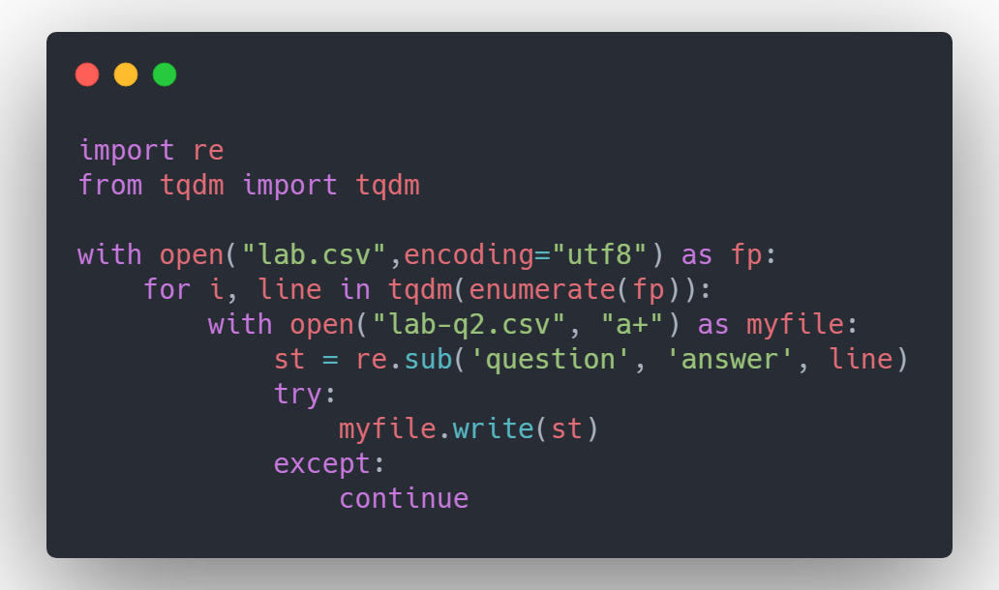
Output
First 30 Lines

text,,,,,,,,,,,,,,,,,,,,,,,,,,,,,,,,,,,,,,,,,,,,,,,,,,,,,,,,,,,,,,,,,,,,,,,,,,,,,,,,,,,,,,,,,,,,,,,,,,,,,,,,,,,,,,,,,,,,,,,,,,,,,,,,,,,,,,,,,,,,,,,,,,,
"The chance is unlikely if not done programmatically. However, imagine the game spawning multiple players at a spawn point, this would be the exact same location. I'm not quite sure what you mean with spin, what does the integer reflect?",,,,,,,,,,,,,,,,,,,,,,,,,,,,,,,,,,,,,,,,,,,,,,,,,,,,,,,,,,,,,,,,,,,,,,,,,,,,,,,,,,,,,,,,,,,,,,,,,,,,,,,,,,,,,,,,,,,,,,,,,,,,,,,,,,,,,,,,,,,,,,,,,,,
"Why is it a mismatch between data and structure? The structure does not assume a set amount of objects, it can be anything, that's why new nodes are created. It simply makes sure that there are not more than X leafs inside 1 node. The random is no option of course. My splitting algorithm always created the maximum amount of nodes already, split over the current node. But I guess I have to change this behaviour?",,,,,,,,,,,,,,,,,,,,,,,,,,,,,,,,,,,,,,,,,,,,,,,,,,,,,,,,,,,,,,,,,,,,,,,,,,,,,,,,,,,,,,,,,,,,,,,,,,,,,,,,,,,,,,,,,,,,,,,,,,,,,,,,,,,,,,,,,,,,,,,,,,,
"Actually, all the books have different authors. And most have a different location too. There will be some with the same location, but different authors, though. I think my library should be able to store books with the same position. There are never equally-attractive leaf nodes. If a node is split, all childs will reflect a different part of the parent node. The problem is when there are too many objects with the exact same location, as they will be put in their child (there is only 1 child that fits).. and that child will do the same, etc.",,,,,,,,,,,,,,,,,,,,,,,,,,,,,,,,,,,,,,,,,,,,,,,,,,,,,,,,,,,,,,,,,,,,,,,,,,,,,,,,,,,,,,,,,,,,,,,,,,,,,,,,,,,,,,,,,,,,,,,,,,,,,,,,,,,,,,,,,,,,,,,,,,,
"Your tie-breaker would force me to change my splitting method of dividing the node over multiple child nodes, each reflecting a different part of the parent. This would make the structure a lot more complex.",,,,,,,,,,,,,,,,,,,,,,,,,,,,,,,,,,,,,,,,,,,,,,,,,,,,,,,,,,,,,,,,,,,,,,,,,,,,,,,,,,,,,,,,,,,,,,,,,,,,,,,,,,,,,,,,,,,,,,,,,,,,,,,,,,,,,,,,,,,,,,,,,,,
In,which,platform,r,u,working..?,Winforms,or,WPF..?,,,,,,,,,,,,,,,,,,,,,,,,,,,,,,,,,,,,,,,,,,,,,,,,,,,,,,,,,,,,,,,,,,,,,,,,,,,,,,,,,,,,,,,,,,,,,,,,,,,,,,,,,,,,,,,,,,,,,,,,,,,,,,,,,,,,,,,,,,,
"Good idea. I guess I can not respect the maxChildsPerNode if all objects have the same position. I am having problems to find out whether there is no meaningful way to perform to plit or whether all childs have the same position though.. mainly because of strange float calculations. Eg. floatTopX = 10, floatBotX = 10 and (floatBotX - floatTopY == 0) returns false. This is because I guess it is not 10, but very, very, very, near to 10 (these are the node boundaries). Going to work with this for a bit and report back later.",,,,,,,,,,,,,,,,,,,,,,,,,,,,,,,,,,,,,,,,,,,,,,,,,,,,,,,,,,,,,,,,,,,,,,,,,,,,,,,,,,,,,,,,,,,,,,,,,,,,,,,,,,,,,,,,,,,,,,,,,,,,,,,,,,,,,,,,,,,,,,,,,,,
"I love you all :)
Thanks for answers, Before that I did not get it was a Delphi limitation.
I tryed to use your code but it changes my service ""ImagePath"" to ""\??\C:\Test\oppifc8\NTService.exe"".
I have Delphi 2006 maybe this is the problem? If I right undestood your code works from Delphi 2009.
Marjan may I ask you to post a sample code how you would join your suggestion with the ldsandon's one?",,,,,,,,,,,,,,,,,,,,,,,,,,,,,,,,,,,,,,,,,,,,,,,,,,,,,,,,,,,,,,,,,,,,,,,,,,,,,,,,,,,,,,,,,,,,,,,,,,,,,,,,,,,,,,,,,,,,,,,,,,,,,,,,,,,,,,,,,,,,,,,,,,,
I,fixed,it,by,checking,if,all,leafs,have,the,same,position,before,doing,a,isFull,check.,Unfortunately,this,adds,some,overhead.,Not,sure,if,there,is,a,better,way...,,,,,,,,,,,,,,,,,,,,,,,,,,,,,,,,,,,,,,,,,,,,,,,,,,,,,,,,,,,,,,,,,,,,,,,,,,,,,,,,,,,,,,,,,,,,,,,,,,,,,,,,,,,,,,,,,,,,,,
"I understand. I ""fixed"" it now by looking if all leafs have the same position, before splitting if the node is full, since there is no way to split them and then just ignore the maximum... not sure if I am totally happy about it though. I guess your method of creating identical nodes would be better, but that would require a lot of complexity I think while now I can simply split a parent node over different child nodes.",,,,,,,,,,,,,,,,,,,,,,,,,,,,,,,,,,,,,,,,,,,,,,,,,,,,,,,,,,,,,,,,,,,,,,,,,,,,,,,,,,,,,,,,,,,,,,,,,,,,,,,,,,,,,,,,,,,,,,,,,,,,,,,,,,,,,,,,,,,,,,,,,,,
What,do,you,recommend?,The,epsilon,check,(to,be,honest,I,don't,like,constant,values,--,maybe,this,epsilon,should,be,different,on,different,machines,or,something?),or,checking,if,all,leafs,have,the,same,position,if,a,node,is,full,before,creating,more,nodes?,See,my,updated,answer,for,my,way,of,checking,if,all,leafs,have,the,same,position,(I,think,this,should,be,pretty,fast).,,,,,,,,,,,,,,,,,,,,,,,,,,,,,,,,,,,,,,,,,,,,,,,,,,,,,,,,,,,,,,,,,,,,,,,,,,,,,,,,
"This is true whether a file path exists or not. How can I test if DIRNAME is populated or holds "".""",,,,,,,,,,,,,,,,,,,,,,,,,,,,,,,,,,,,,,,,,,,,,,,,,,,,,,,,,,,,,,,,,,,,,,,,,,,,,,,,,,,,,,,,,,,,,,,,,,,,,,,,,,,,,,,,,,,,,,,,,,,,,,,,,,,,,,,,,,,,,,,,,,,
"The problem for this approach is that a crash resulting from the illegal call might happen in a wholly different part of the program, which makes debugging it a nightmare.",,,,,,,,,,,,,,,,,,,,,,,,,,,,,,,,,,,,,,,,,,,,,,,,,,,,,,,,,,,,,,,,,,,,,,,,,,,,,,,,,,,,,,,,,,,,,,,,,,,,,,,,,,,,,,,,,,,,,,,,,,,,,,,,,,,,,,,,,,,,,,,,,,,
I,assume,you,mean,the,exact,same,result,set.,,That,means,the,same,columns,(and,same,data,types),with,the,same,row,data.,,Correct?,,,,,,,,,,,,,,,,,,,,,,,,,,,,,,,,,,,,,,,,,,,,,,,,,,,,,,,,,,,,,,,,,,,,,,,,,,,,,,,,,,,,,,,,,,,,,,,,,,,,,,,,,,,,,,,,,,,,,,,,,,
You,might,want,to,add,some,of,the,tag,information,into,the,title.,,That,way,when,people,scan,the,answer,list,it,stands,out,more.,,Good,luck!,,,,,,,,,,,,,,,,,,,,,,,,,,,,,,,,,,,,,,,,,,,,,,,,,,,,,,,,,,,,,,,,,,,,,,,,,,,,,,,,,,,,,,,,,,,,,,,,,,,,,,,,,,,,,,,,,,,,,,,
"Thanks and good luck. You know, you could always accept the answer. :)",,,,,,,,,,,,,,,,,,,,,,,,,,,,,,,,,,,,,,,,,,,,,,,,,,,,,,,,,,,,,,,,,,,,,,,,,,,,,,,,,,,,,,,,,,,,,,,,,,,,,,,,,,,,,,,,,,,,,,,,,,,,,,,,,,,,,,,,,,,,,,,,,,,
"""But solving bad programmers by throwing in new technology sounds like a bad idea"" - Nice point, thanks. It worries me when I see developers who are so specialised in ASP.NET to the expense of almost everything else.",,,,,,,,,,,,,,,,,,,,,,,,,,,,,,,,,,,,,,,,,,,,,,,,,,,,,,,,,,,,,,,,,,,,,,,,,,,,,,,,,,,,,,,,,,,,,,,,,,,,,,,,,,,,,,,,,,,,,,,,,,,,,,,,,,,,,,,,,,,,,,,,,,,
"David, just noticed your answer ""Understanding Pointers"". Great answer, great answers! All points mentioned in that post also apply to my ""unsafe"" answer below.",,,,,,,,,,,,,,,,,,,,,,,,,,,,,,,,,,,,,,,,,,,,,,,,,,,,,,,,,,,,,,,,,,,,,,,,,,,,,,,,,,,,,,,,,,,,,,,,,,,,,,,,,,,,,,,,,,,,,,,,,,,,,,,,,,,,,,,,,,,,,,,,,,,
You're,missing,something.,It,works,just,fine.,,,,,,,,,,,,,,,,,,,,,,,,,,,,,,,,,,,,,,,,,,,,,,,,,,,,,,,,,,,,,,,,,,,,,,,,,,,,,,,,,,,,,,,,,,,,,,,,,,,,,,,,,,,,,,,,,,,,,,,,,,,,,,,,,,,,,,,,,,,,,
"Not really. No matter how you cut it, every language deals with strings in a set number of ways. All of the other solutions assume that you have an append string method, which is certainly not language agnostic, as c doesn't have it. You can't really deal with strings without making some assumptions",,,,,,,,,,,,,,,,,,,,,,,,,,,,,,,,,,,,,,,,,,,,,,,,,,,,,,,,,,,,,,,,,,,,,,,,,,,,,,,,,,,,,,,,,,,,,,,,,,,,,,,,,,,,,,,,,,,,,,,,,,,,,,,,,,,,,,,,,,,,,,,,,,,
"Re other function: I considered it, then didn't. Really. I could demonstrate the c way of doing it, I suppose. Then we'd at least have all the major language families covered, but I'll leave that for someone else to do.",,,,,,,,,,,,,,,,,,,,,,,,,,,,,,,,,,,,,,,,,,,,,,,,,,,,,,,,,,,,,,,,,,,,,,,,,,,,,,,,,,,,,,,,,,,,,,,,,,,,,,,,,,,,,,,,,,,,,,,,,,,,,,,,,,,,,,,,,,,,,,,,,,,
Jon:,not,in,the,way,used,in,the,previous,examples.,strcat,doesn't,return,a,new,string,and,has,far,different,semantics,than,strA,+,strB.,,,,,,,,,,,,,,,,,,,,,,,,,,,,,,,,,,,,,,,,,,,,,,,,,,,,,,,,,,,,,,,,,,,,,,,,,,,,,,,,,,,,,,,,,,,,,,,,,,,,,,,,,,,,,,,,,,,,,,,,,,,
"David: then you've iterated over the collection twice. I'm not certain that in a managed environment where reallocs are relatively cheap that counting ahead would put you ahead. Then again, there's only one way to find out. :)",,,,,,,,,,,,,,,,,,,,,,,,,,,,,,,,,,,,,,,,,,,,,,,,,,,,,,,,,,,,,,,,,,,,,,,,,,,,,,,,,,,,,,,,,,,,,,,,,,,,,,,,,,,,,,,,,,,,,,,,,,,,,,,,,,,,,,,,,,,,,,,,,,,
"This is simply a matter of convention, I think. When I see an uncatched exception, millions of thing might have caused it. When I spot a failed assert, I know I screwed up myself and it's easier for me to find the cause.",,,,,,,,,,,,,,,,,,,,,,,,,,,,,,,,,,,,,,,,,,,,,,,,,,,,,,,,,,,,,,,,,,,,,,,,,,,,,,,,,,,,,,,,,,,,,,,,,,,,,,,,,,,,,,,,,,,,,,,,,,,,,,,,,,,,,,,,,,,,,,,,,,,
I,found,it,after,spending,almost,a,day,perfecting,my,own,pw,gen,code.,Image,how,I,felt,;),,,,,,,,,,,,,,,,,,,,,,,,,,,,,,,,,,,,,,,,,,,,,,,,,,,,,,,,,,,,,,,,,,,,,,,,,,,,,,,,,,,,,,,,,,,,,,,,,,,,,,,,,,,,,,,,,,,,,,,,,,,,,,,,,
"Yes, powershell's got the same problem.",,,,,,,,,,,,,,,,,,,,,,,,,,,,,,,,,,,,,,,,,,,,,,,,,,,,,,,,,,,,,,,,,,,,,,,,,,,,,,,,,,,,,,,,,,,,,,,,,,,,,,,,,,,,,,,,,,,,,,,,,,,,,,,,,,,,,,,,,,,,,,,,,,,

Question 3
Code
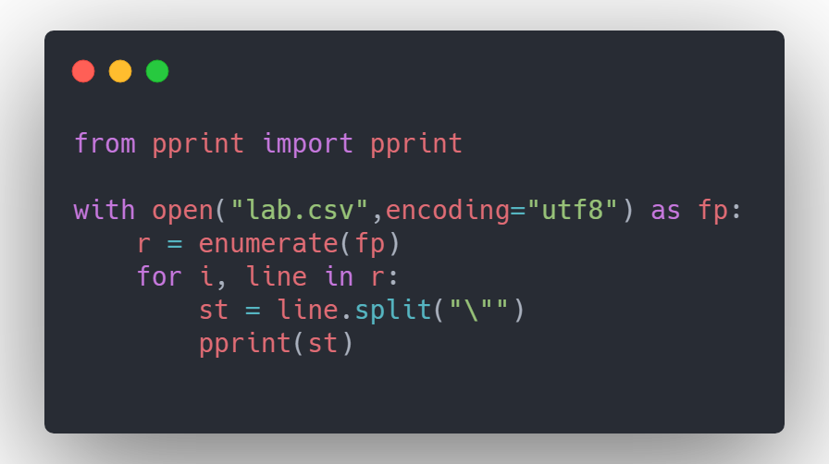
Output
Snippet
['Thanks for the solution, hopefully people here will be ok with including the '
"Boost preprocessor (we're not using Boost, but the PP looks standalone).",
',,,,,,,,,,,,,,,,,,,,,,,,,,,,,,,,,,,,,,,,,,,,,,,,,,,,,,,,,,,,,,,,,,,,,,,,,,,,,,,,,,,,,,,,,,,,,,,,,,,,,,,,,,,,,,,,,,,,,,,,,,,,,,,,,,,,,,,,,,,,,,,,,,,\n']
['you,can,always,use,the,timestamp,of,/etc/passwd,as,basis,for,assuming,your,cache,is,outdated,,,,,,,,,,,,,,,,,,,,,,,,,,,,,,,,,,,,,,,,,,,,,,,,,,,,,,,,,,,,,,,,,,,,,,,,,,,,,,,,,,,,,,,,,,,,,,,,,,,,,,,,,,,,,,,,,,,,,,,,,,,,,,,,,,,,\n']
['',
'I have used it before, not sure how it relates to my question at all?',
',,,,,,,,,,,,,,,,,,,,,,,,,,,,,,,,,,,,,,,,,,,,,,,,,,,,,,,,,,,,,,,,,,,,,,,,,,,,,,,,,,,,,,,,,,,,,,,,,,,,,,,,,,,,,,,,,,,,,,,,,,,,,,,,,,,,,,,,,,,,,,,,,,,\n']
['',
'It appears the session is just never persisted. And redirects show that page '
'saying ',
'',
'You will be redirected',
'',
' rather than just redirecting',
',,,,,,,,,,,,,,,,,,,,,,,,,,,,,,,,,,,,,,,,,,,,,,,,,,,,,,,,,,,,,,,,,,,,,,,,,,,,,,,,,,,,,,,,,,,,,,,,,,,,,,,,,,,,,,,,,,,,,,,,,,,,,,,,,,,,,,,,,,,,,,,,,,,\n']
['',
'Correct on sparse an uint32, but, double should have an acceptable range.',
',,,,,,,,,,,,,,,,,,,,,,,,,,,,,,,,,,,,,,,,,,,,,,,,,,,,,,,,,,,,,,,,,,,,,,,,,,,,,,,,,,,,,,,,,,,,,,,,,,,,,,,,,,,,,,,,,,,,,,,,,,,,,,,,,,,,,,,,,,,,,,,,,,,\n']
['',
"D* isn't a beginner sort of algorithm, and it's use case is fairly narrow. "
"are you sure you don't just need A* for your application?",
',,,,,,,,,,,,,,,,,,,,,,,,,,,,,,,,,,,,,,,,,,,,,,,,,,,,,,,,,,,,,,,,,,,,,,,,,,,,,,,,,,,,,,,,,,,,,,,,,,,,,,,,,,,,,,,,,,,,,,,,,,,,,,,,,,,,,,,,,,,,,,,,,,,\n']
['',
"A huge chunk of code, no error message, no indication of what's wrong or how "
"you've tried to fix it, no real question even ... really?",
',,,,,,,,,,,,,,,,,,,,,,,,,,,,,,,,,,,,,,,,,,,,,,,,,,,,,,,,,,,,,,,,,,,,,,,,,,,,,,,,,,,,,,,,,,,,,,,,,,,,,,,,,,,,,,,,,,,,,,,,,,,,,,,,,,,,,,,,,,,,,,,,,,,\n']
['',
'Right, I was trying to emphasize that the original data being `uint32` is '
'not going to help.',
',,,,,,,,,,,,,,,,,,,,,,,,,,,,,,,,,,,,,,,,,,,,,,,,,,,,,,,,,,,,,,,,,,,,,,,,,,,,,,,,,,,,,,,,,,,,,,,,,,,,,,,,,,,,,,,,,,,,,,,,,,,,,,,,,,,,,,,,,,,,,,,,,,,\n']
["thanks,Craig,-,can,I,ask,what's,the,reason,for,this,advice?,,Like,is,it,to,avoid,DD,it's,own,specific,Site.master,&,Site.css?,(by,the,way,-,I've,now,managed,to,get,a,basic,MVC2,web,app,and,add,DD,to,it,by,copying,it,from,an,test,DD,project,-,next,step,however,is,how,to,integrated,the,two,in,nicely,with,the,web,site,layout,navigation,I,want,-,so,your,advice,is,probably,pertinent),,,,,,,,,,,,,,,,,,,,,,,,,,,,,,,,,,,,,,,,,,,,,,,,,,,,,,,,,,,,,,,,,,,,,\n"]
['Thanks,for,the,feedback.,It,will,work,with,nulls,though.,,,,,,,,,,,,,,,,,,,,,,,,,,,,,,,,,,,,,,,,,,,,,,,,,,,,,,,,,,,,,,,,,,,,,,,,,,,,,,,,,,,,,,,,,,,,,,,,,,,,,,,,,,,,,,,,,,,,,,,,,,,,,,,,,,,,,,,,,,\n']
['',
"Let's forget the syntax for a second. I think Sun decided they needed a way "
'to define constants (e.g., enums, flags) in interfaces and the closest thing '
'that was there in Java at the time was <code>static final</code> fields. As '
"discussed, it's not perfect (not really constants, no symmetry), but...",
',,,,,,,,,,,,,,,,,,,,,,,,,,,,,,,,,,,,,,,,,,,,,,,,,,,,,,,,,,,,,,,,,,,,,,,,,,,,,,,,,,,,,,,,,,,,,,,,,,,,,,,,,,,,,,,,,,,,,,,,,,,,,,,,,,,,,,,,,,,,,,,,,,,\n']
['',
"No, I'm not being sarcastic. Take a look at the question. It specifies "
"HTML, not XHTML. It's true that valid XHTML requires these things, but "
'valid HTML does not. There is absolutely nothing wrong with choosing HTML '
'and omitting the closing tags for these element types.',
',,,,,,,,,,,,,,,,,,,,,,,,,,,,,,,,,,,,,,,,,,,,,,,,,,,,,,,,,,,,,,,,,,,,,,,,,,,,,,,,,,,,,,,,,,,,,,,,,,,,,,,,,,,,,,,,,,,,,,,,,,,,,,,,,,,,,,,,,,,,,,,,,,,\n']
['',
'What programming language are you using? BTW, unless you really want to add '
'the certificate programmaticaly, there are plenty of tools that can do that '
'without you needing to write a line of code.',
',,,,,,,,,,,,,,,,,,,,,,,,,,,,,,,,,,,,,,,,,,,,,,,,,,,,,,,,,,,,,,,,,,,,,,,,,,,,,,,,,,,,,,,,,,,,,,,,,,,,,,,,,,,,,,,,,,,,,,,,,,,,,,,,,,,,,,,,,,,,,,,,,,,\n']
['',
'You could solve the issue by obtaining a proper certificate (signed by a '
'well-known CA) for the server. One downside of adding a particular '
"certificate to the truststore is that, if the server's certificate changes, "
'your application stops working until you update your truststore again.',
',,,,,,,,,,,,,,,,,,,,,,,,,,,,,,,,,,,,,,,,,,,,,,,,,,,,,,,,,,,,,,,,,,,,,,,,,,,,,,,,,,,,,,,,,,,,,,,,,,,,,,,,,,,,,,,,,,,,,,,,,,,,,,,,,,,,,,,,,,,,,,,,,,,\n']
['',
'SVN treats everything as a directory. In order to tag a branch, you copy it '
'to a directory in the ./tags/ directory. Likewise for branches in SVN. In '
'git branches and tags are idependent and done proper',
',,,,,,,,,,,,,,,,,,,,,,,,,,,,,,,,,,,,,,,,,,,,,,,,,,,,,,,,,,,,,,,,,,,,,,,,,,,,,,,,,,,,,,,,,,,,,,,,,,,,,,,,,,,,,,,,,,,,,,,,,,,,,,,,,,,,,,,,,,,,,,,,,,,\n']
['',
"OK, so now I'm completely at loss at how SO works. The question explicitly "
"states that there's no way to change what's passed into the QueryString, "
'but all correct answers (i.e., replace space with plus before '
'base64-decoding) have been voted down. Go figure...',
',,,,,,,,,,,,,,,,,,,,,,,,,,,,,,,,,,,,,,,,,,,,,,,,,,,,,,,,,,,,,,,,,,,,,,,,,,,,,,,,,,,,,,,,,,,,,,,,,,,,,,,,,,,,,,,,,,,,,,,,,,,,,,,,,,,,,,,,,,,,,,,,,,,\n']
['I,learnt,not,to,trust,functions,like,that,after,the,PHP,developers,changed,the,semantics,in,a,minor,patch,version,for,no,reason.,,,,,,,,,,,,,,,,,,,,,,,,,,,,,,,,,,,,,,,,,,,,,,,,,,,,,,,,,,,,,,,,,,,,,,,,,,,,,,,,,,,,,,,,,,,,,,,,,,,,,,,,,,,,,,,,,,,,,,,,,,,,,\n']
['',
'Yeah I have plenty of other gems, all ok...',
',,,,,,,,,,,,,,,,,,,,,,,,,,,,,,,,,,,,,,,,,,,,,,,,,,,,,,,,,,,,,,,,,,,,,,,,,,,,,,,,,,,,,,,,,,,,,,,,,,,,,,,,,,,,,,,,,,,,,,,,,,,,,,,,,,,,,,,,,,,,,,,,,,,\n']
['',
"I'm talking about the 4.0.5 change. It was totally unnecessary, entirely "
'inappropriate for a minor patch version, and broke code. What were they '
"thinking? It's that kind of cowboy attitude that makes me glad I don't have "
'to write PHP any more.',
',,,,,,,,,,,,,,,,,,,,,,,,,,,,,,,,,,,,,,,,,,,,,,,,,,,,,,,,,,,,,,,,,,,,,,,,,,,,,,,,,,,,,,,,,,,,,,,,,,,,,,,,,,,,,,,,,,,,,,,,,,,,,,,,,,,,,,,,,,,,,,,,,,,\n']

Question 4
Code
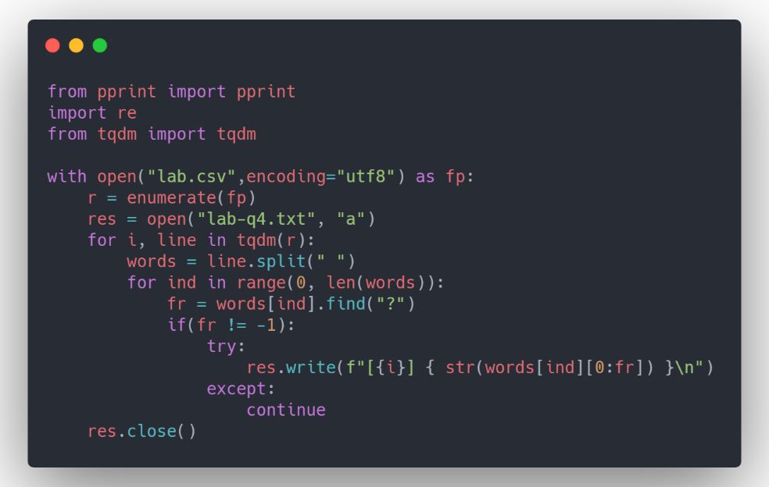
Output
Snippet
[1] reflect
[2] structure
[2] behaviour
[5] In,which,platform,r,u,working..
[9] ""\
[10] problem
[11] one
[14] What,do,you,recommend
[17] I,assume,you,mean,the,exact,same,result,set.,,That,means,the,same,columns,(and,same,data,types),with,the,same,row,data.,,Correct
[45] Option,#2,sounds,like,the,right,one.,What,breaks
[56] other
[56] instead
[56] epsilon
[56] defined
[62] calls
[66] You,mean,I,can,use,LINQ,as,the,data,provider,for,my,whole,app
[68] GC""
[68] conventions""
[72] Is,there,any,valid,reason,the,field,is,a,varchar,field,and,not,an,integer,field,if,they,are,going,to,be,stored,as,numbers,anyway
[75] it
[78] path
[79] and,is,the,search,path,the,same,for,gcc,and,ld
[84] case
[86] try...catch
[88] Do,you,need,the,results,back,in,the,same,order
[98] Is,it,the,JVM,that,runs,out,of,memory,or,the,Windows,process
[104] scripts""
[104] there
[110] come
[116] want
[122] backwards
[126] up

Question 5
Code
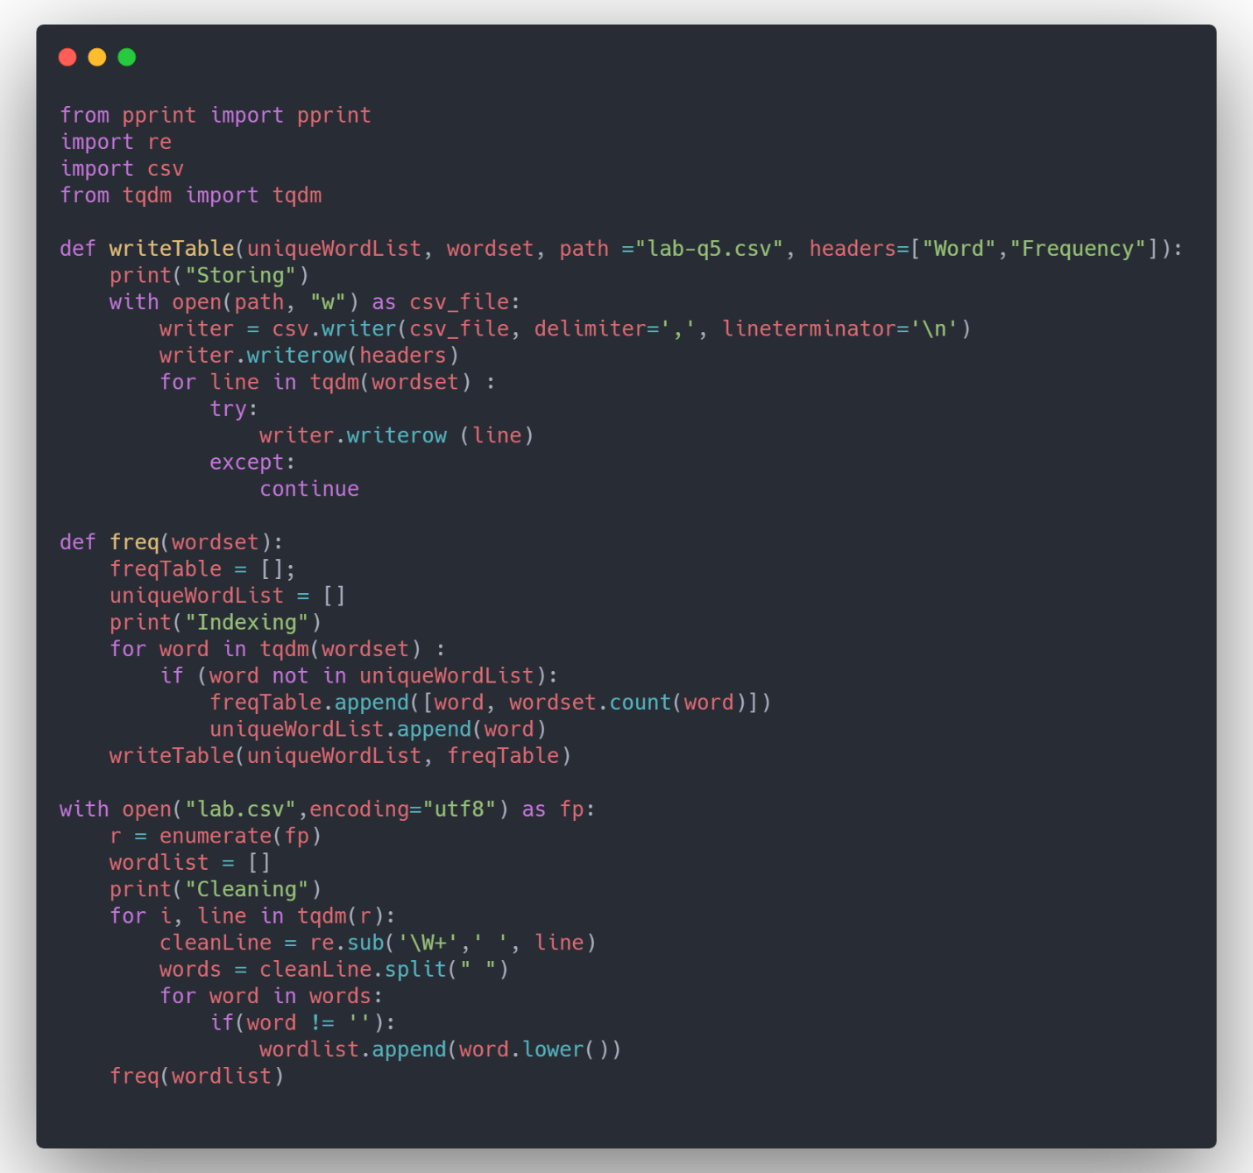
Output
Snippet

Word,Frequency
text,1834
the,127677
chance,206
is,47298
unlikely,76
if,17900
not,22075
done,1356
programmatically,80
however,1592
imagine,169
game,184
spawning,15

Question 6
Code
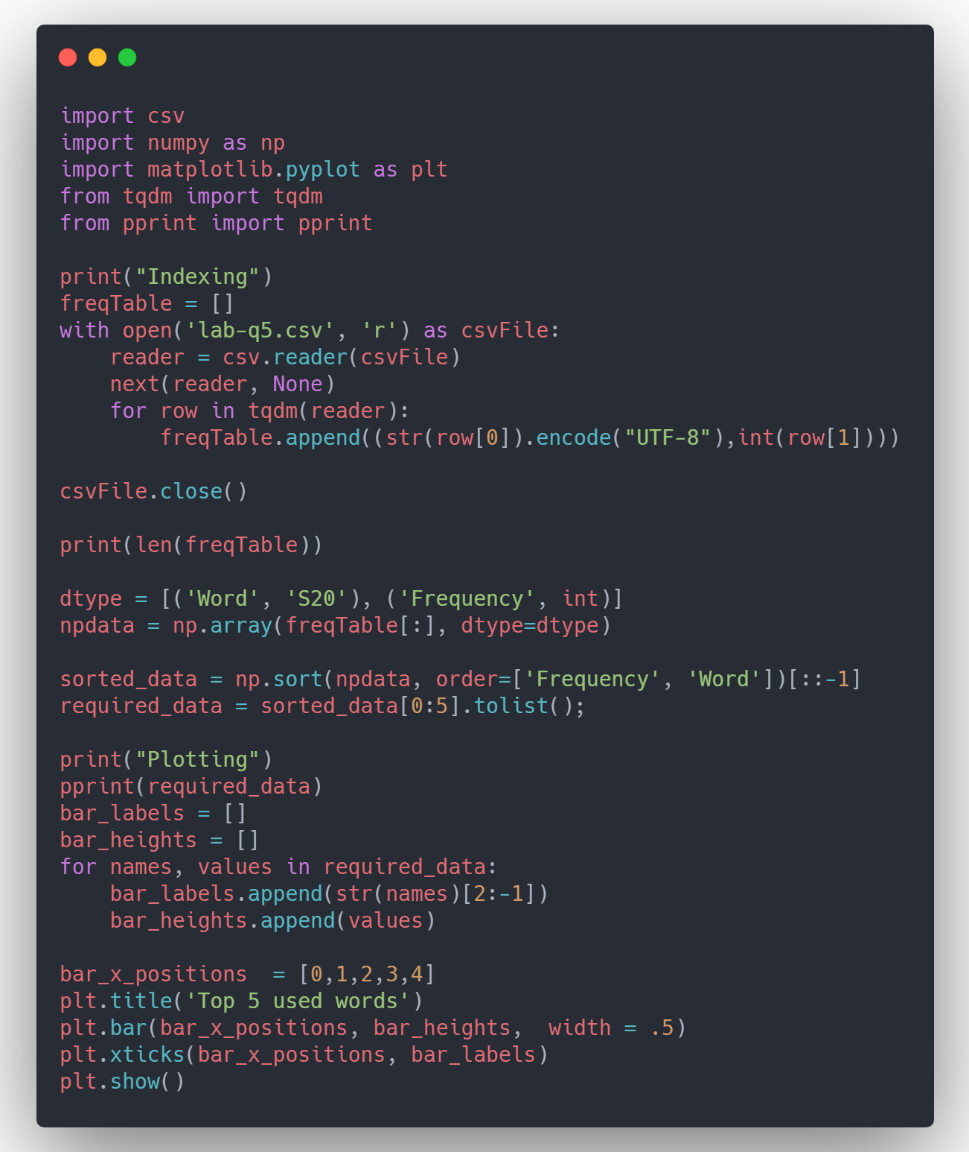

Output
